Task1:::

.model small

.stack

.data

var1 db ?;1

var2 db ?;5

.code

mov ax,@data

mov ds,ax

mov bl,var1

sub bl,48

mov bh,var2

sub bh,48

add bl,bh

add bl,48

mov dl,bl

mov ah,02h

int 21h

mov ah,4ch

int 21h

end

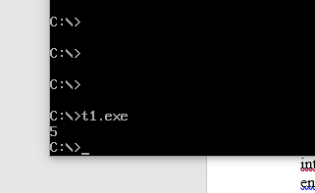

Task2

.model small

.stack

.data

var1 db ?

var2 db ?

.code

mov ax,@data

mov ds,ax

mov ah,01

int 21h

sub al,48

mov var1,al

mov bl,var1

mov ah,01h

int 21h

sub al,48

mov var2,al

mov cl,var2

add bl,cl

add bl,48

mov ah,02h

mov dl,bl

int 21h

mov ah,4ch

int 21h

end



Task 3 9-3

.model small

.stack

.data

var1 db 57

var2 db 51

.code

mov ax,@data

mov ds,ax

mov bl,var1

sub bl,48

mov bh,var2

sub bh,48

sub bl,bh

add bl,48

mov ah,02h

mov dl,bl

int 21h

mov ah,4ch

int 21h

end

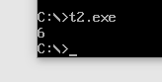

Task4

.model small

.stack

.data

var1 db ?

var2 db ?

.code

mov ax,@data

mov ds,ax

mov ah,01

int 21h

sub al,48

mov var1,al

mov bl,var1

mov ah,01h

int 21h

sub al,48

mov var2,al

mov cl,var2

sub bl,cl

add bl,48

mov ah,02h

mov dl,bl

int 21h

mov ah,4ch

int 21h

end

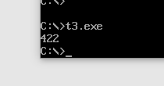

Task 5 4\*1

.model small

.stack

.data

.code

mov ax,@data

mov ds,ax

mov al,1

mov bl,4

mul bl

add al,48

mov ah,02h

mov dl,al

int 21h

mov ah,4ch

int 21h

end

